**ASSIGNMENT NO 2**

**Shivam Navnath Giri**

**CDAC PGDAI SILCHAR**

**Q1. Chess Agents :**

**Consider two intelligent agents playing chess with a clock. One of them is called “Deep**

**Blue” while the other is called Gary Kasparov.**

**Specify the task environment in terms of “PEAS”**

**Specify the Properties of this task environment.**

**Solution :**

**Chess Agents: Deep Blue vs Gary Kasparov**

**PEAS for Chess with a Clock:**

1. **Performance Measure (P)**:
   * Winning the game (checkmate or opponent's resignation).
   * Minimizing time taken (as they are playing with a clock).
   * Maximizing the score (in some cases, based on piece advantage).
2. **Environment (E)**:
   * A **two-player** turn-based environment with an 8x8 chessboard.
   * The chess pieces and board state (locations of all pieces).
   * The clock, which limits the time each player has to make decisions.
3. **Actuators (A)**:
   * Moving the chess pieces on the board.
   * Managing the clock (choosing when to end the turn).
   * Visualizing the board and computing the next move for Deep Blue (in the case of the machine).
4. **Sensors (S)**:
   * For **Gary Kasparov**: Vision (seeing the board and pieces), touch (moving pieces), and time awareness (keeping track of the clock).
   * For **Deep Blue**: Input from the board state (digital representation), clock time data, and internal evaluation of the current game position using algorithms.

**Properties of the Chess Task Environment:**

1. **Fully Observable**: Both agents (Deep Blue and Kasparov) have complete visibility of the board and all pieces at all times.
2. **Deterministic**: The outcome of each action (moving a piece) is perfectly predictable. There is no randomness in the game.
3. **Sequential**: The game progresses through a sequence of moves, where each move influences future states and actions.
4. **Static**: The environment doesn’t change while a player is deciding their move (it’s static between turns).
5. **Discrete**: The chess game has a finite number of possible states (piece positions) and moves. Both the board and time are discrete.
6. **Competitive (Multi-agent)**: It involves two competing agents, each trying to outsmart the other to win the game.

**Q2. Design State space for agent which:**

**- Can move in four directions up, down, right and left**

**- Can sense heat in cell on left or right or up or down**

**- Environment is rectangle of size n by m**

**- Environment has agent, a lion and home**

**- Goal of the agent is to reach home**

**- All cells adjacent to lion have heat**

**- If Agent goes to adjacent cell to lion then agent loses**

**Write conditions for movement precisely and design the space tree**

**Solution :**

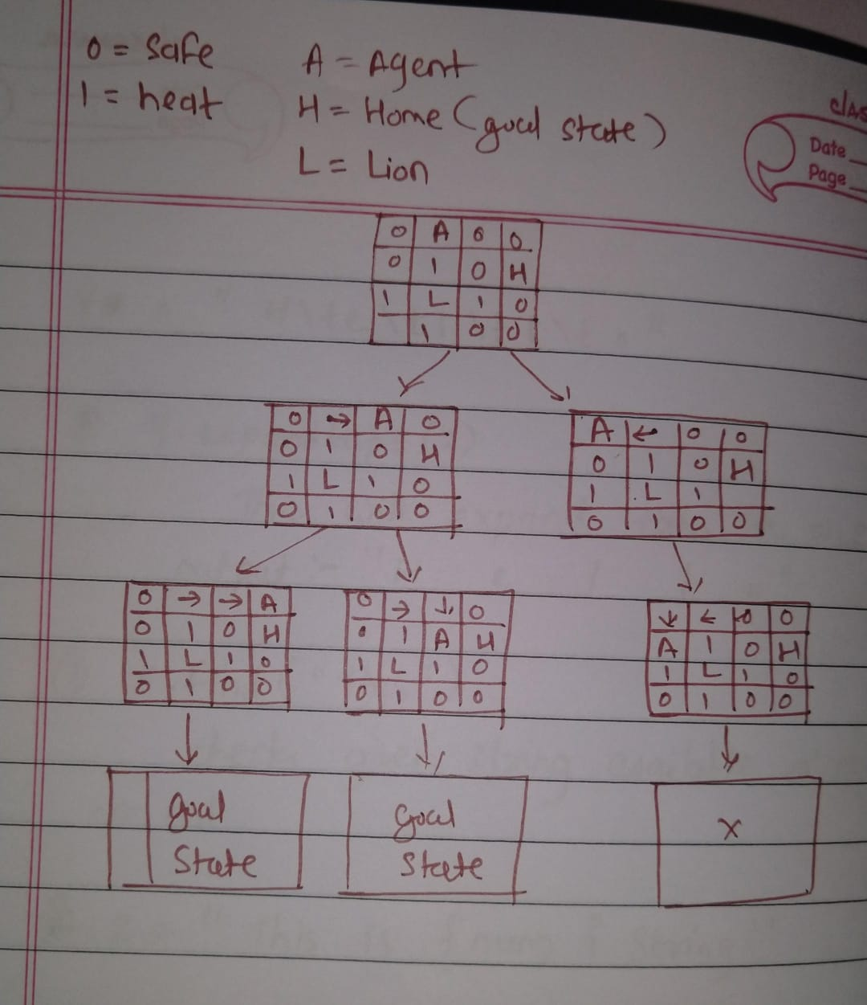

**Q3. The missionaries and cannibals problem is usually stated as follows. Three missionaries and three cannibals are on one side of a river, along with a boat that can hold one or two people. Find a way to get everyone to the other side without ever leaving a group of missionaries in one place outnumbered by the cannibals in that place. This problem is famous in AI because it was the subject of the first paper that approached problem formulation from an analytical viewpoint (Amarel, 1968). Formulate the problem precisely, making only those distinctions necessary to ensure a valid solution. Draw a diagram of the complete state space.**

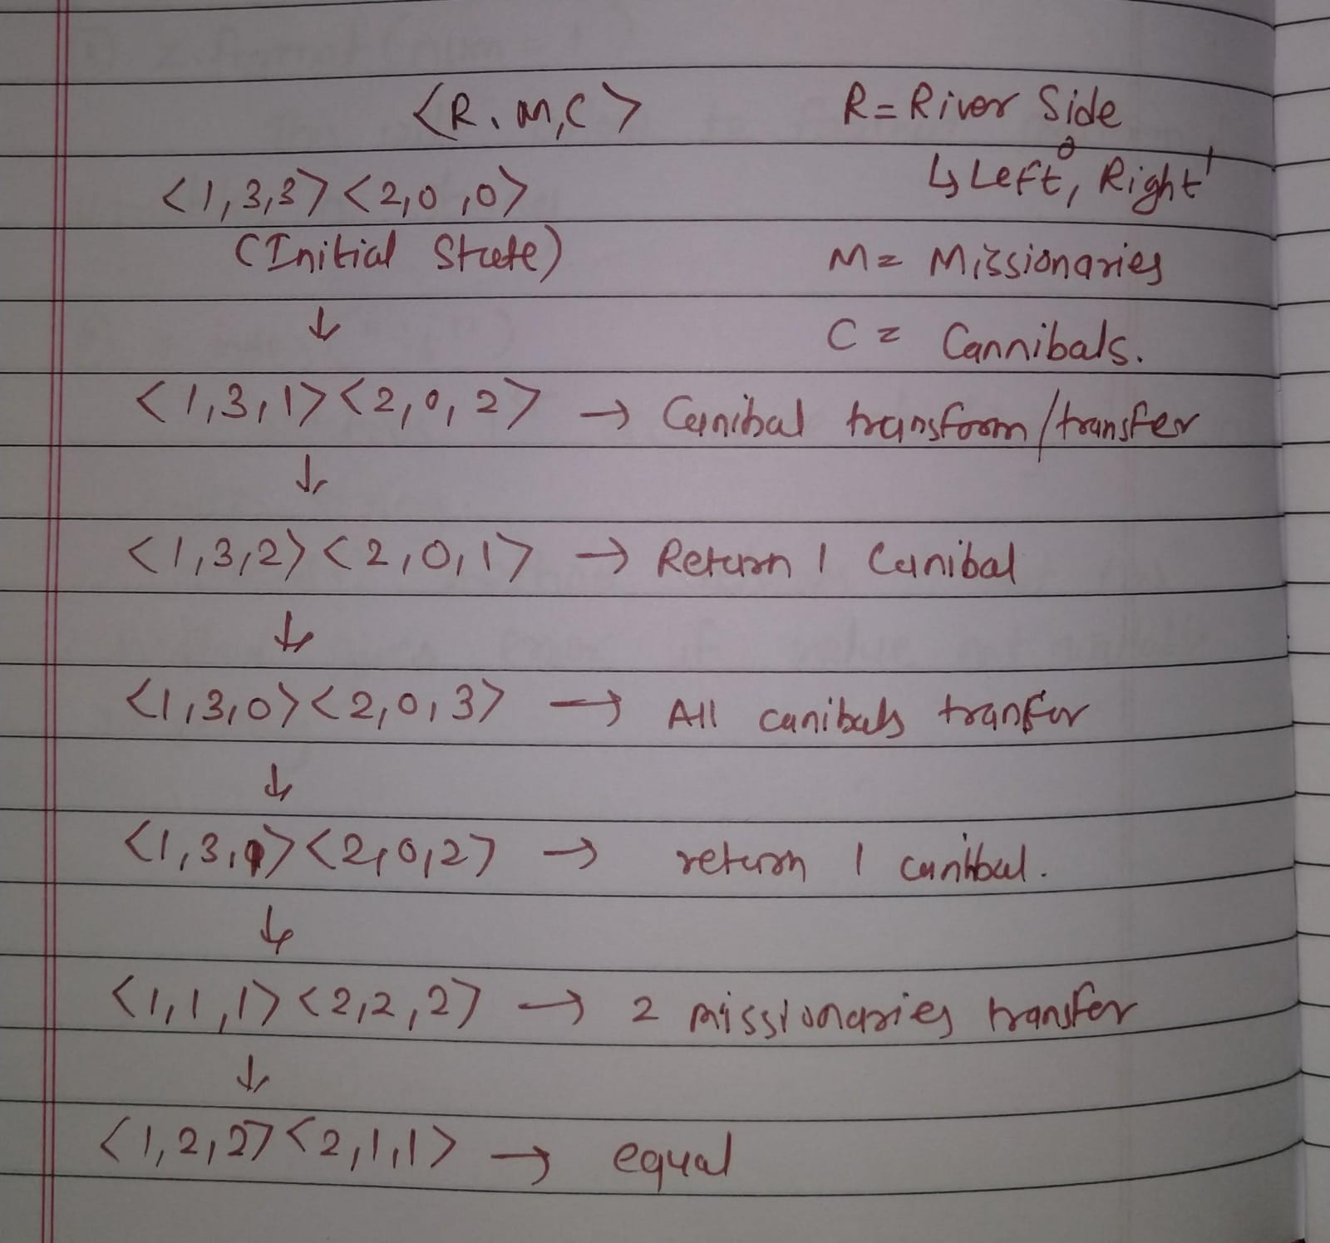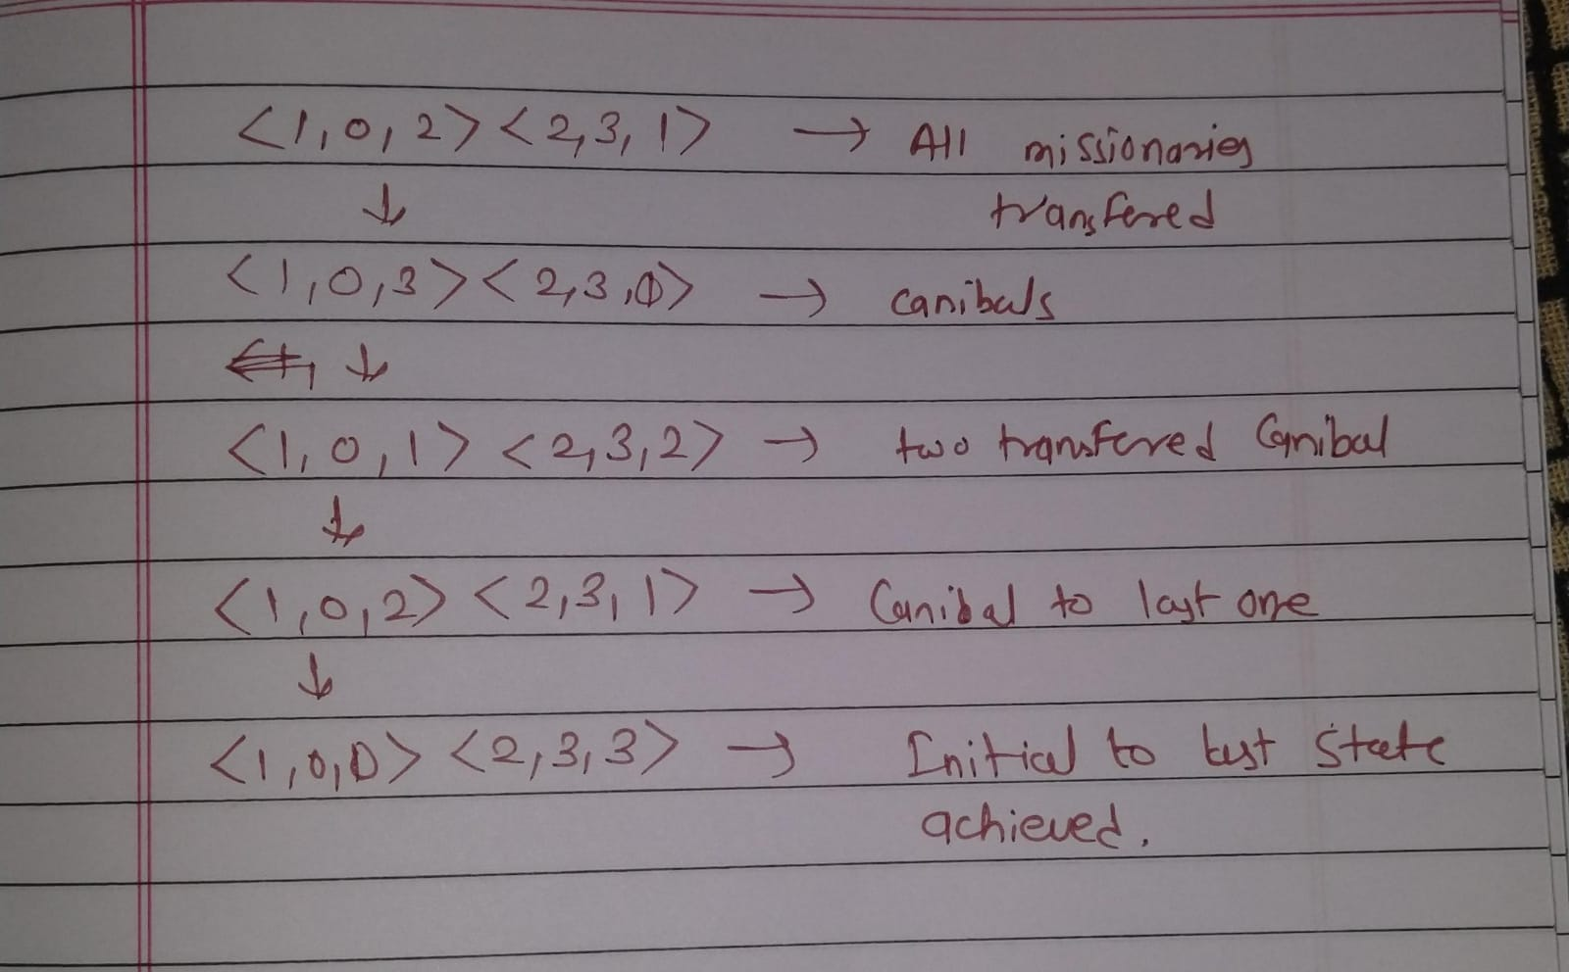

**Q4. Draw a diagram of the complete state space for block world problem in AI.**

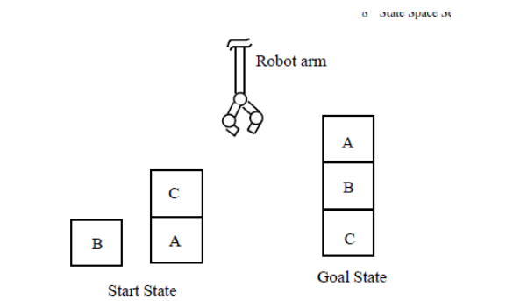

**Assume that following rules for moves will be followed by the robot arm for**

**carrying out this job:**

**• stack(x, y): stack block x on block y,**

**• lift(x): lift-up the block x,**

**• putg(x): put block x on ground,**

**• unstack(x, y): unstack block x from block y.**

